**Table of Contents**

1. **Flight Checklists**
   1. Pre-Flight Checklist – Before Leaving For Field
   2. Field Setup
   3. Pre-Flight Checklist – In—Field
   4. In-Flight Checklist – At-Field
   5. Post-Flight Checklist
   6. Ground Truthing and Agronomic Notes (Optional)
2. **How-to Guide**
   1. CHDK Installation on SD Card
   2. Camera Settings
   3. Mission Planner Program and Driver Installation
   4. Ground Map Caching on Mission Planner
   5. Mission Planning
   6. Downloading Data Flash Logs
   7. Preparing Data For Archiving
3. ABCD
4. ABCD

**Table of Figures**

Figure 1:

1. **Preflight Checklist – Before Leaving for Field**

* Does RC Transmitter have enough voltage? FrSky transmitter should have ≥ 9.4V.
* Are UAV batteries charged? 3 cell batteries should charge to 12.6V
* Is laptop charged? Do you need/have a laptop charger?
* Cached map? (See section x.x below)
* Accessory list:
  + Transmitter with sufficient battery power
  + Radio with USB cable
  + Propellers and extra propellers
  + Tool kit (wrench set, propeller hex-key, camera mount screw and screw driver etc.)
  + Camera(s) with extra batteries and SD cards with CHDK installed
  + Gimbal (optional)
  + UAV batteries and battery chargers
  + Voltmeter (optional)
  + ColorChecker or Calibration board (optional)
  + GCP installed (optional)

**PixHawk Driver installation troubleshooting steps:**

- Download the latest PX4FLOW driver from here:

<https://pixhawk.org/firmware/downloads>

- Go to device manager (control panel > device manager). Instructions on installing the downloaded .inf driver file:

<https://pixhawk.org/users/px4flow_windows_driver>

- In case the windows does not like the unverified drivers we will have to disable the security function. To disable the windows security feature: <https://pixhawk.org/users/drivers_win>

**2. Camera settings (Based on Canon PowerShot S100 camera)**

* Shoot in Manual mode
* Two Camera settings can be used:

1. **Manual (M)** mode:

* + Shutter speed: fastest or close to fastest (for S100 canon, 1/1250 - 1/2000 would work, depending upon the UAV speed and weather condition)
  + ISO: ~80-250 (adjust based on ambient light). Tip: Higher ISO, brighter image and higher noise.
  + Aperture (f-number): 4.0-5.6. Tip: Small f-number means wider apertures, which gives shallow depth of field. In our experience, F-number of 4-5.6 is like a sweet spot. It is recommended that you play around with the manual settings to setup your camera based on your requirements.
  + Ev (exposure): -1/3 or -2/3. Again, adjust based on ambient light conditions.
  + **Note**: Use the vertical bar with moving pointer to adjust the camera settings to get proper exposure (not too bright and dark). The pointer should point at or below the mid-mark.

2. **Shutter Priority** (**Tv)** mode:

* + In **Tv** mode only shutter needs to be adjusted, ISO and F-number will be automatically adjusted by camera.
  + Shutter speed: fastest or close to fastest (for S100 canon, 1/1250, 1/1600, or 1/2000 would work, depending upon the light conditions). Quick tip: faster shutters less light hitting the sensor.
  + (optional) **Ev** (exposure): 0, -1/3 or -2/3 (again adjust based on ambient light conditions)
* Set the Manual Focus (**MF**) setting to **infinity** for above 5 meter flights.
* Image recording format: **Camera raw (CR2)**
* Under **MENU** option, turn:
  + **GPS ON**
  + **MF-point ZOOM OFF**
  + **Safety MF OFF**
  + **Wind Filter OFF**

**3. Preflight Checklist – At field before arming**

* Check parameters (see parameter section below)
* Don’t move the UAV immediately after plugging the battery. Because during initial few seconds, the UAV does the automatic sensor-calibration. So avoid any vehicle movement.
* Check if the camera trigger is working by walking certain distance (lock SD card, run script, remote parameters checked in CHDK)
* Check UAV facing towards line of flight (away from you)
* Number of satellites ≥ 9 and 3D fix.
* Check battery voltage
* Check switch positions
* Check trims are zero (offsets to stick positions that can be set with small slide switches)
* Make sure no one is close to UAV or in survey area.
* Make sure the WayPoints are written correctly to the UAV (You can read back the WP from UAV to double check)

**4. In-flight Checklist – At field after arming**

* Arm in stabilized mode
* Once armed, take off in either LOITER or AUTO mode
* Adjust the yaw position and let the UAV go on AUTO
* Keep an eye on UAV during first 3-4 WPs to make sure mission is being followed correctly
* At the completion of the mission, while landing quickly switch to stabilized mode and make sure throttle is all the way down.
* Too big a field to cover in a single battery? You don’t have to create separate missions for that. Use this trick:
  + As soon as the battery hits ~10.8-10.9V, hit RTL (return to launch on controller). UAV will return to launch plot. Make a note of the WP the UAV was about to go to.
  + Replace the battery
  + Launch UAV again using the same plan in **AUTO**.
  + As soon as the UAV hits **Do_Change_Speed** Waypoint, on Mission Planner go to **‘ACTIONS’** menu and choose the WP you want the UAV to go directly to and hit ‘SET’. Now the UAV will jump to the selected WP. Profit !! (Note: It is critical that you let the UAV hit **Do_Change_Speed** and **Do_Set_Cam_Trigger_Distance** WP and then hit the **SET** option.)

**5. Postflight Checklist**

* Always disarm right after landing.
* Make sure to disconnect battery to end the current log.
* Turn off RC transmitter if it’s the last flight.
* Place used battery upside down in box slot to show it needs to be charged and balanced. Keep a small voltmeter in IRIS box so you can check battery status anytime.
* Check camera battery status.
* Fill out flight log. Kevin’s JAVA program. [optional]
* Download log(s) from UAV (see instructions below)
* Download CR2 files from camera.

**Instructions**

**How to Cache Ground Station Map Tiles**

In the Mission Planner Program, hold down ALT key and select part of map to download. Right click and go to MapTool→Prefetch. It will download at current zoom level and then continue downloading at closer and closer zoom levels. To cancel keep clicking Esc key until the box goes away.

**How to plan a mission**

Go to the flight plan tab on mission planner:

Create a polygon around the area of interest (Right click > draw polygon > add polygon point).

When done creating polygon (Right click > draw polygon > save polygon).

Create mission WP (Right click > Auto WP > Survey (Grid)). In the Survey (Grid) window:

1. Under SIMPLE tab several options exist (camera type | altitude | flight speed)
2. Under GRID OPTIONS (Start From | Overlap | Sidelap)
3. Under CAMERA CONFIG (To add a camera for the first time > Load sample image and the program will extract focal length and other information automatically > save the camera).
4. When done, hit ‘Accept’ button under SIMPLE tab.
5. Once the plan is ready, you can add trigger waypoints, change speed and many other for your plan.
6. I use the following mission parameters for most of my flights:
   1. Overlap (>75 %), Sidelap (>75%)
   2. Altitude (10-30m)
   3. Speed (~2-2.5 m/s) [Note: as the flight altitude decreases, change the speed accordingly to get a decent overlap]

**How to Download Dataflash Logs**

Connect to UAV over USB (Radio is too slow).

In Mission Planner on Flight Data page click on the Dataflash Log tab. Then click the Download Dataflash Log Via Mavlink. Select the logs you want to download and then click “Download These Logs”. Immediately go copy them out of the default directory and sort/store them in the correct location.

**Note**: in some windows 8 machines, there seems to be a driver installation problem. Follow the instructions to resolve this issue (credit: Kyle McGahee): <http://diydrones.com/profiles/blogs/windows-8-and-how-to-get-your-apm2-working-on-it>

In my machine, I use these port settings to connect: PX4 FLOW; 115200.

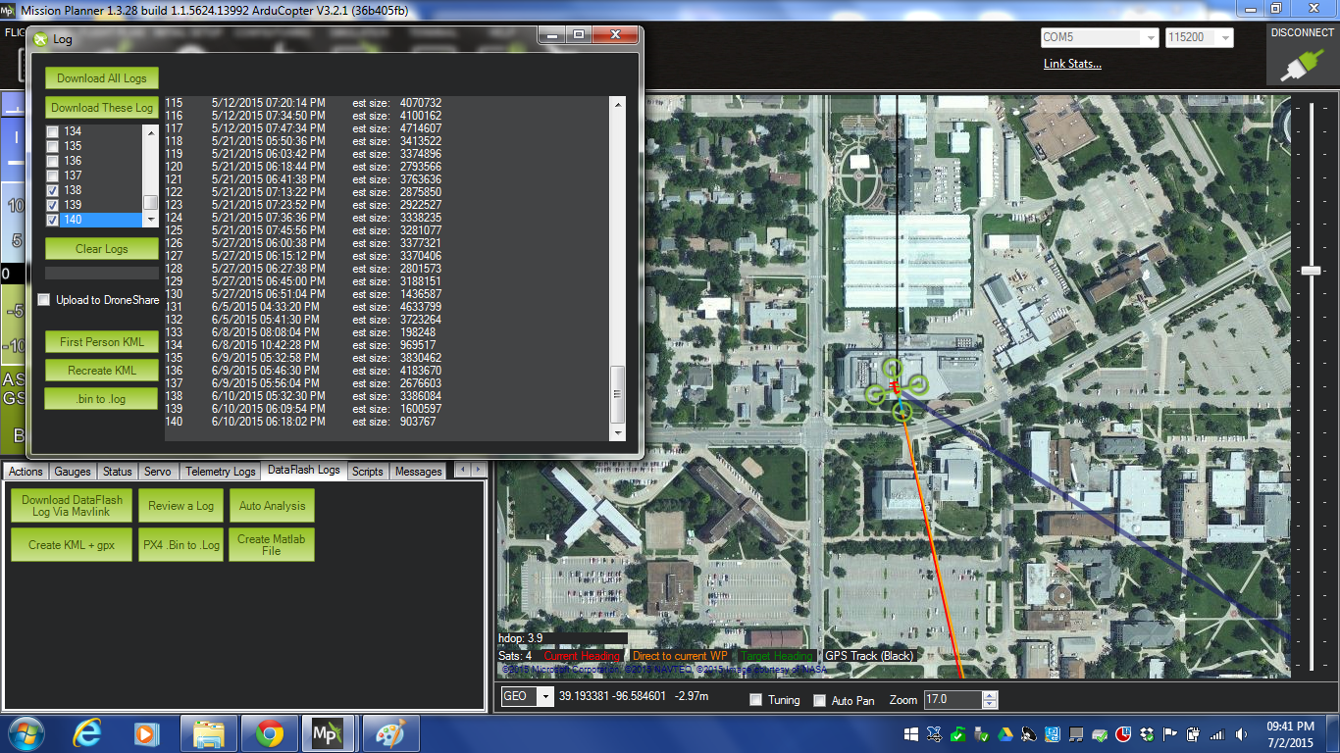

These are screenshots of some useful parameters from mission planner program.

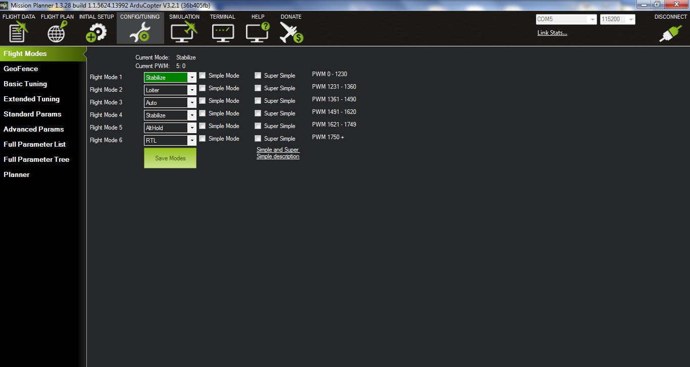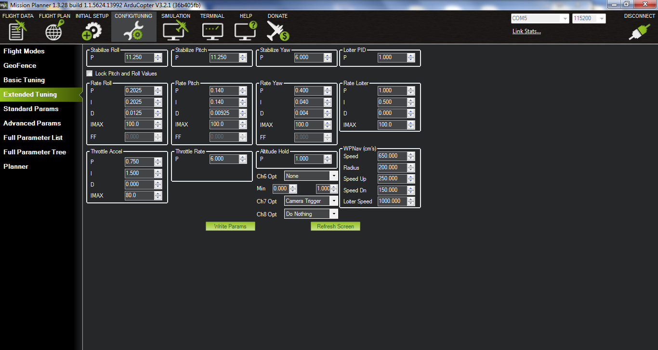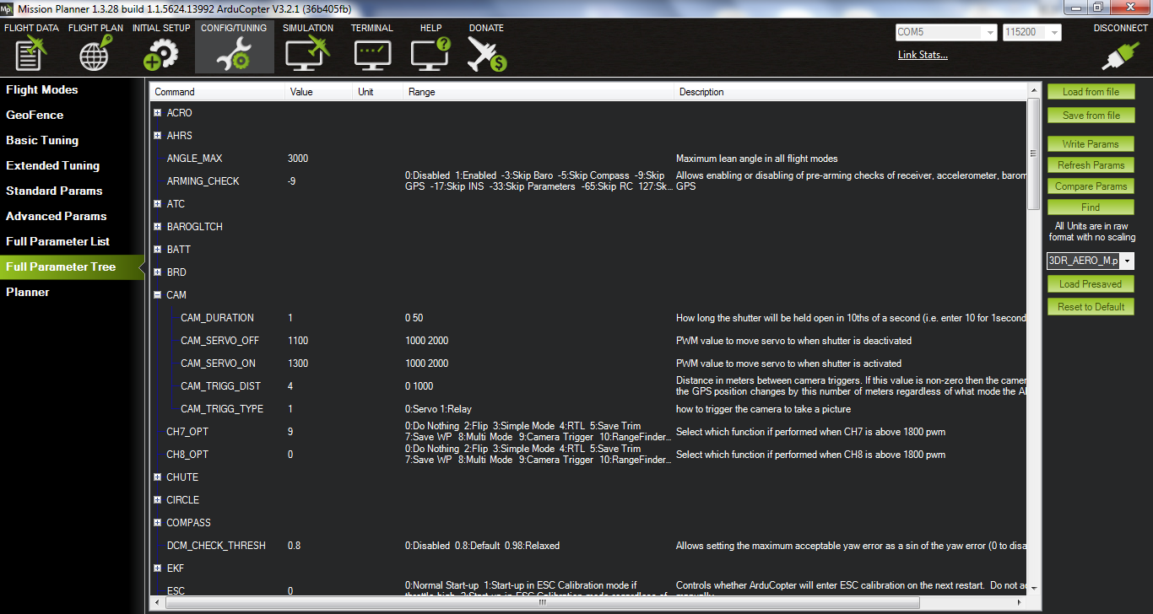

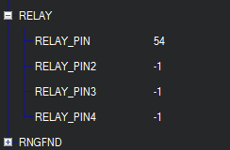

The relay pin 54 lines up with FMU Output 5 on the Pixhawk. (white number 5).

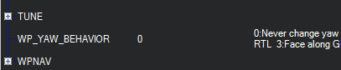

adadad

asasSs

Ssssss

**How to calculate md5 checksum of image data**:

* Calculate md5 checksum of the image data to be transferred to Beocat. Use the following commands in terminal:
  + cd to the directory where data is stored.
  + Example command to calculate the MD5 checksum of all CR2 files in current directory and output directed to text file:  
    openssl md5 *.CR2 > md5_sum.txt
  + The md5 digest is displayed as: MD5([fileName])= [checksum amount].  Example:  
    MD5(IMG_XXXX.CR2)= 287811c077b90af0b013cddf47dcfd69
* Put all .**tlogs** and .**log** files into one folder, zip and upload it on Beocat

**05/18/2015**

“”””””**Tips for new IRIS pilots**“”””””

(From 3DR Facebook page)

* Make sure your have watched all the 3DR Iris tutorial videos before your first flight.
* When first flying your IRIS, make sure to fly it away from people and in an open area
* Before the first flight make sure to do a compass calibration otherwise this could lead to a bad behaviour in GPS enabled modes. You can perform the compass calibration through APM Planner or Mission Plannerhttps://www.youtube.com/watch?v=oD9Z9IR2TNU
* we recommend set your battery failsafe levels to probably say 10.7 if flying manually or 10.8 if using missions. to ensure safe return once battery failsafe is triggered.
* Ensure that you are familiar with the laws of flying UAVs in your country. General laws are 400ft Maximum height and line of sight flying.
* Always switch to Altitude Hold if Loiter or an auto mission is misbehaving since altitude hold doesn't rely on compass or GPS data.
* When changing to other modes not preset by 3DR make sure your throttle has a mid position as your altitude might suddenly decrease or increase when this is not done.
* Alway make sure to disarm IRIS via the safety button when handling.
* If motors do not spin at the same time it might be time to do a ESC calibration

How to create a mission ?

There are several ways to create a mission plan in mission planner program. Here is the one that I prefer which involves placing polygon points manually at each corners of the field. I call it walking around with iris method. Note that this method requires IRIS connected to the mission planner through radio. Here are the steps:

1. Open mission planner program. FLIGHT PLAN > RIGHT-Click on the map window > Draw Polygon > Add polygon points. Now you are in the polygon editing mode.

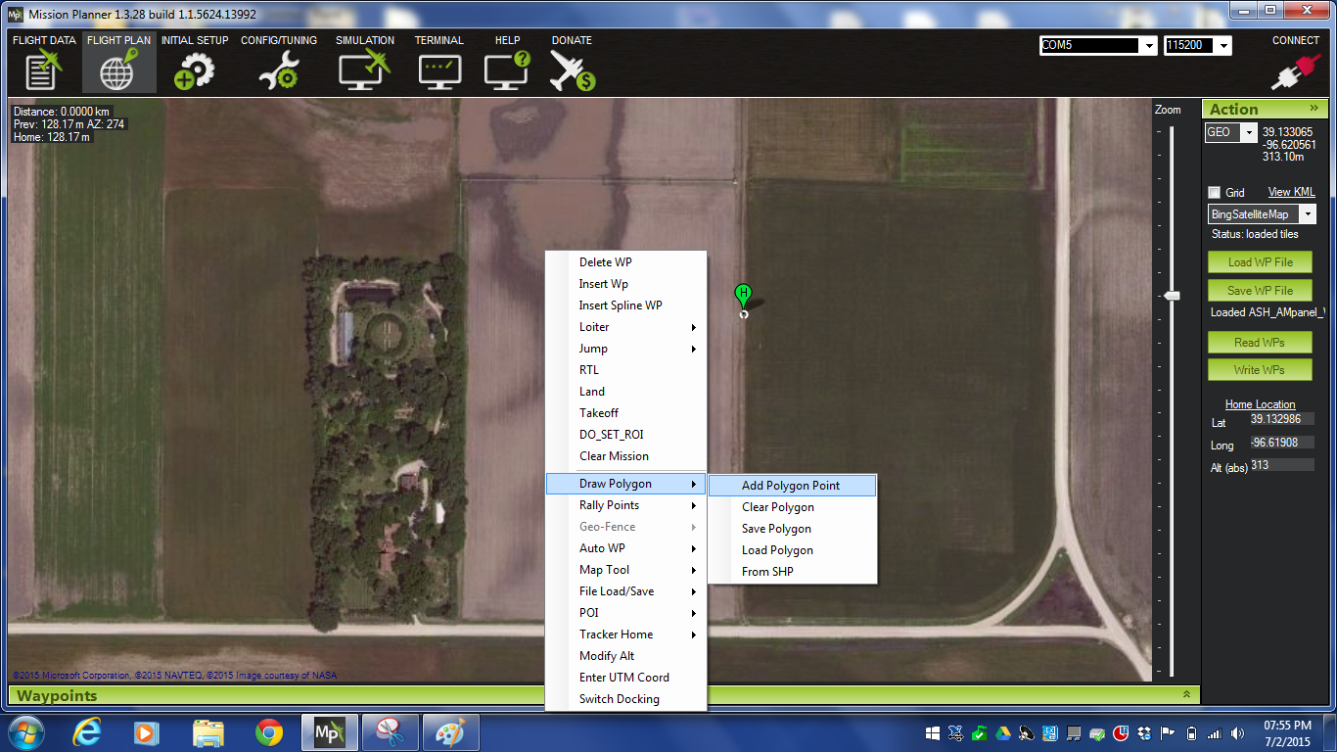

1. Move the iris to the four corners of the field and place polygon markers at each corner.

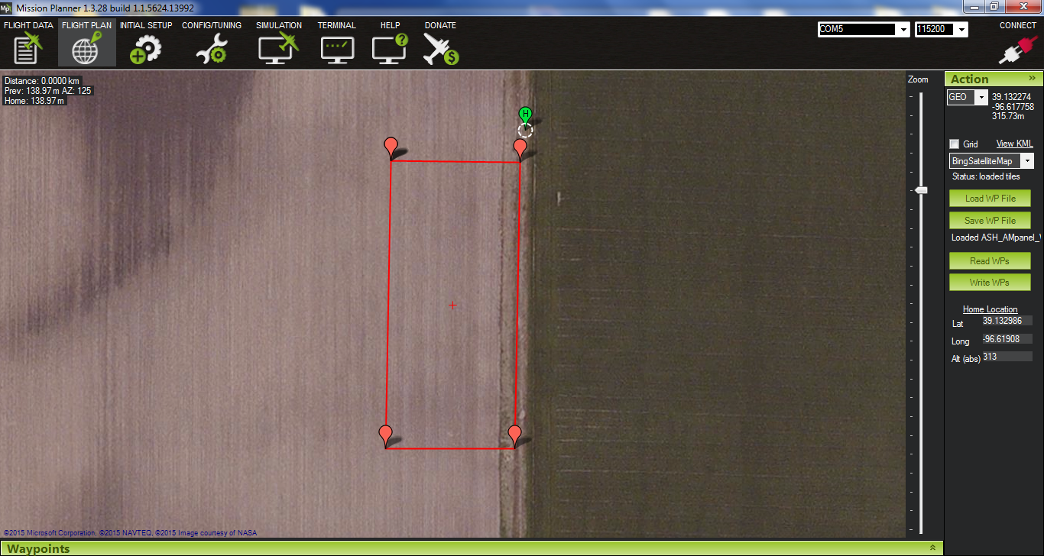

1. Right click on the window > Auto WP > Survey(Grid)

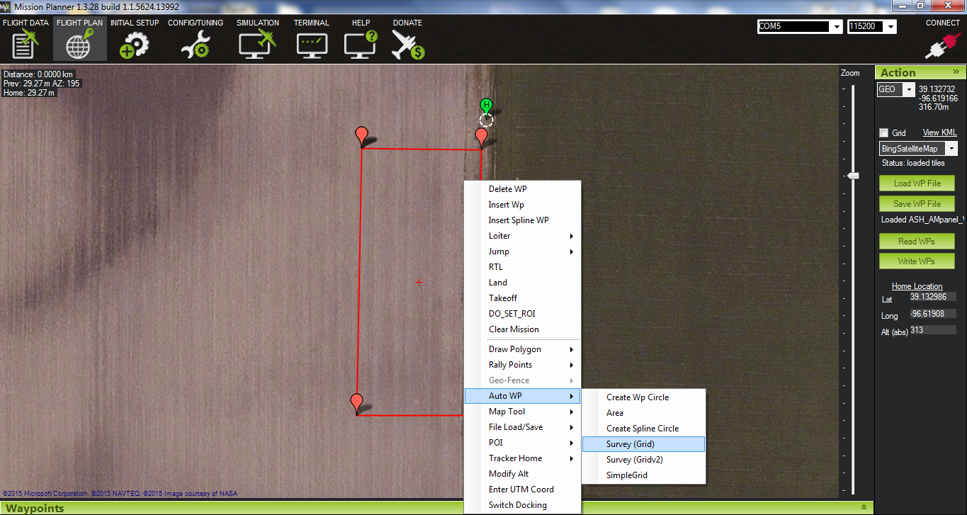

1. In the survey grid window under the sample tab choose the camera, altitude, and flying speed.

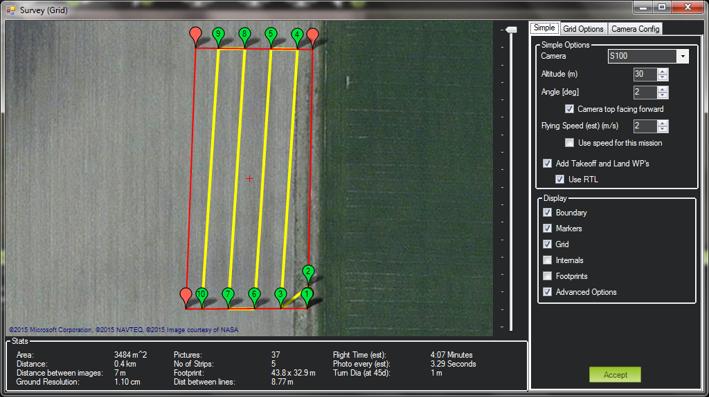

1. Under the grid options tab choose the desired overlap and sidelap. (Note: In order to generate good quality orthomosaics more than 80% forward and 60% side overlap is generally recommended.

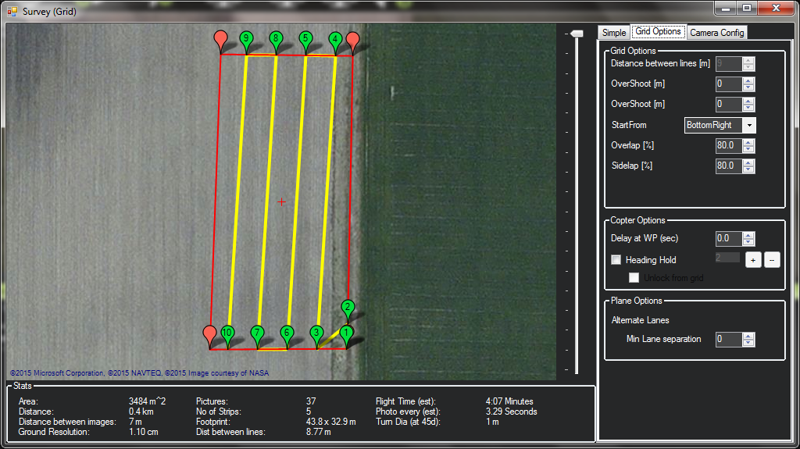

1. Camera Config tab is important when you want to add a new camera or change the focal length of existing camera in Mission Planner for the first time. You basically load a sample photo from same camera that you want to use for your mission. The software will read the exif information from that photo and saves settings for future calculation purposes. 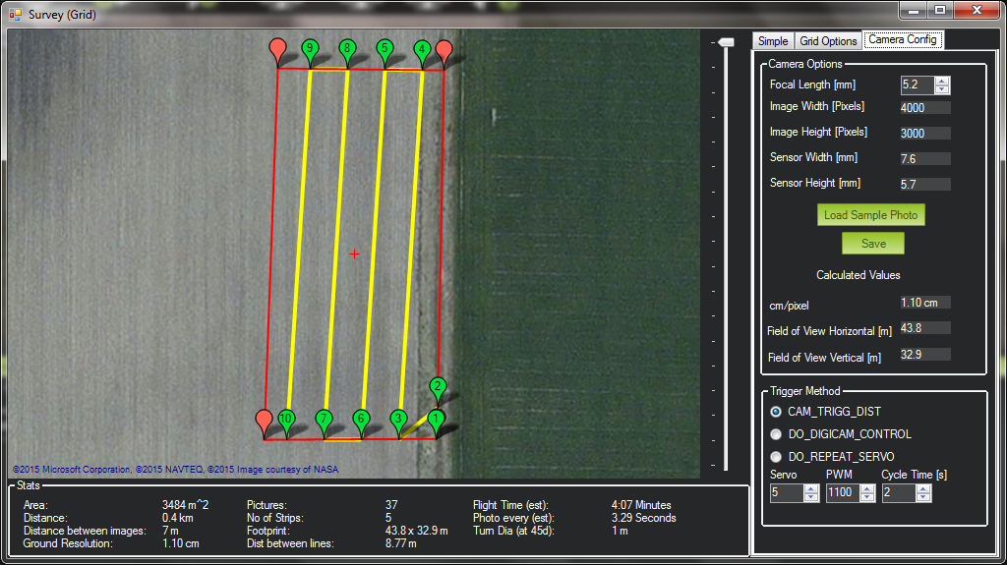
2. Edit waypoints and add cam_trigger and DO_CHANGE_SPEED parameters

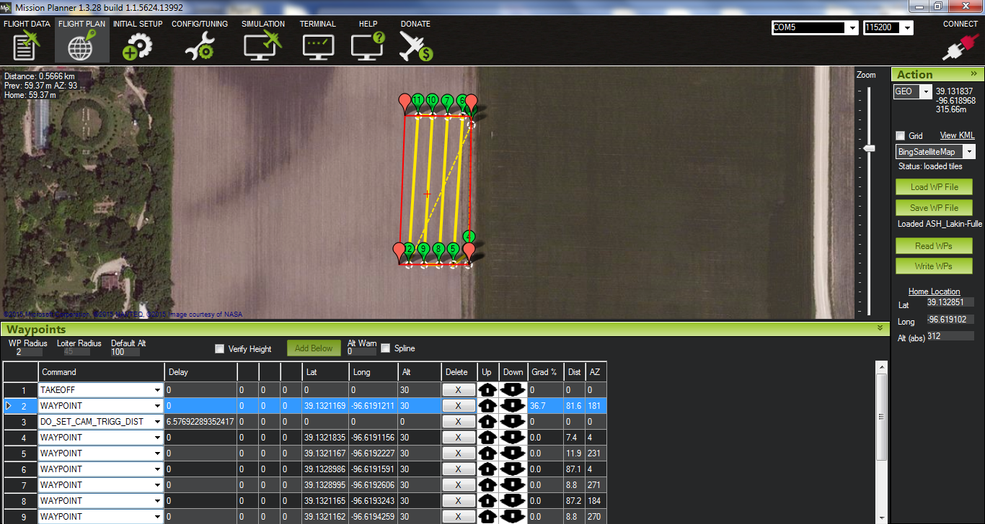

1. Abdcdfdfdff

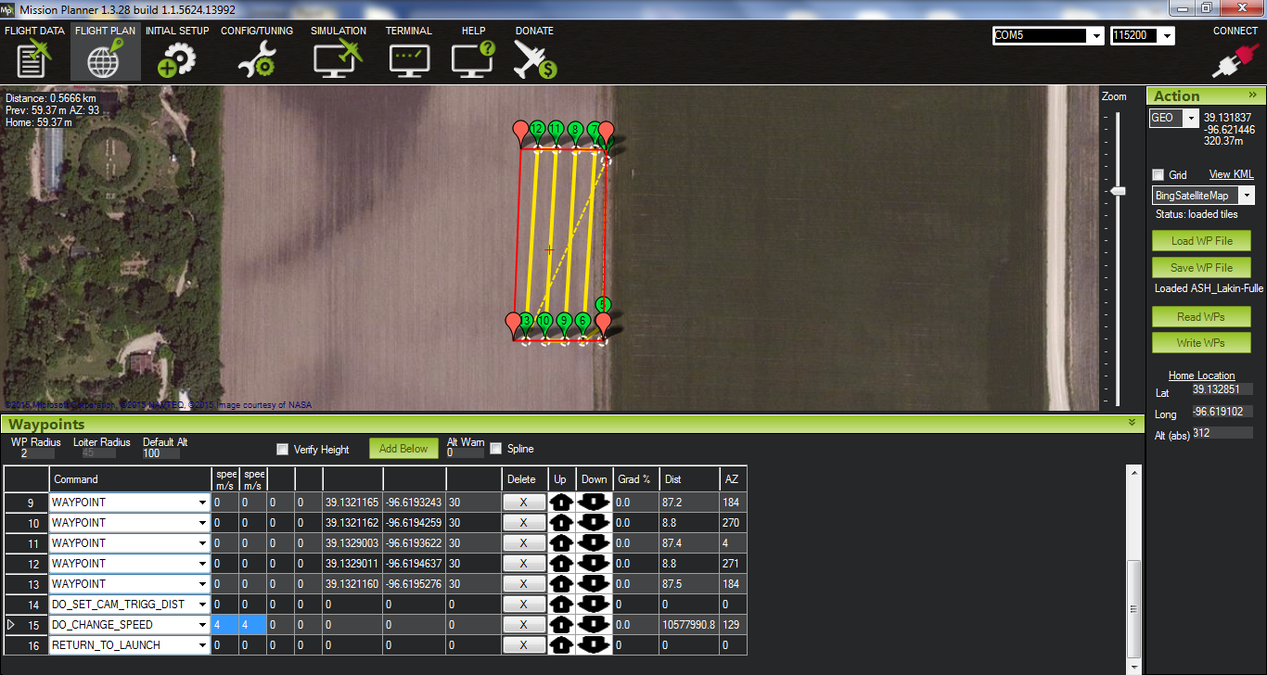

1. Dsdsdsfs

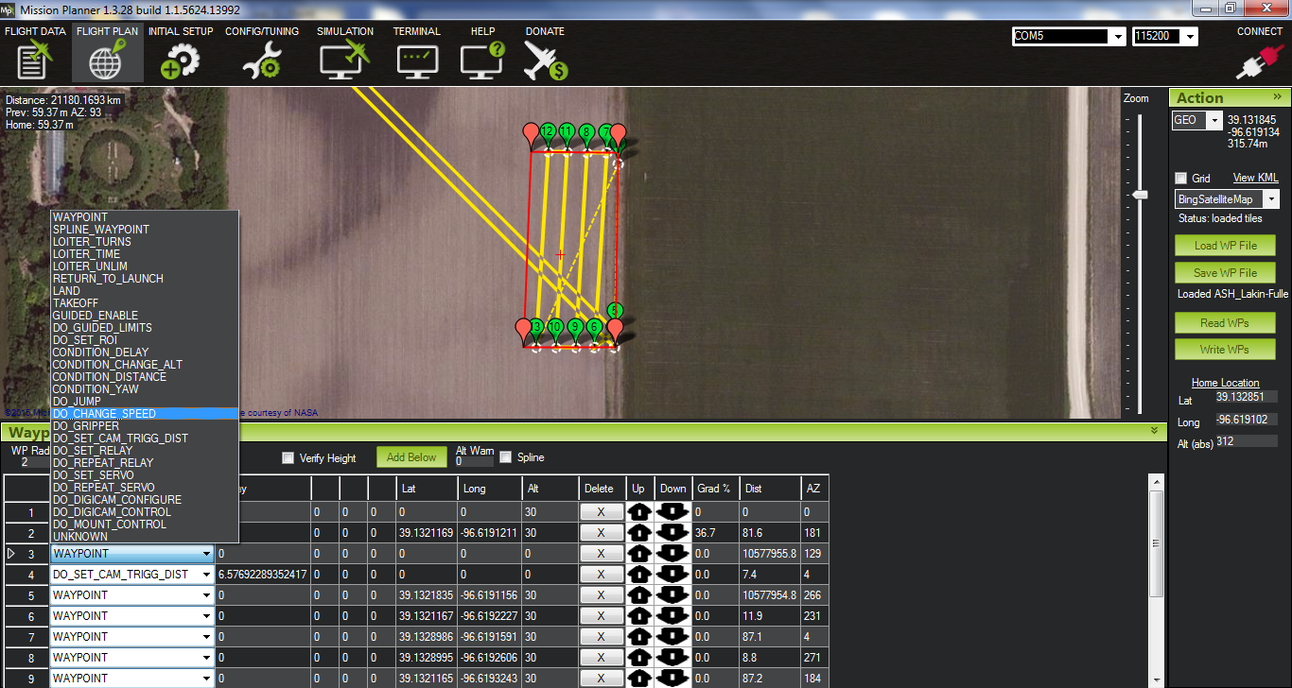

1. ….adadad

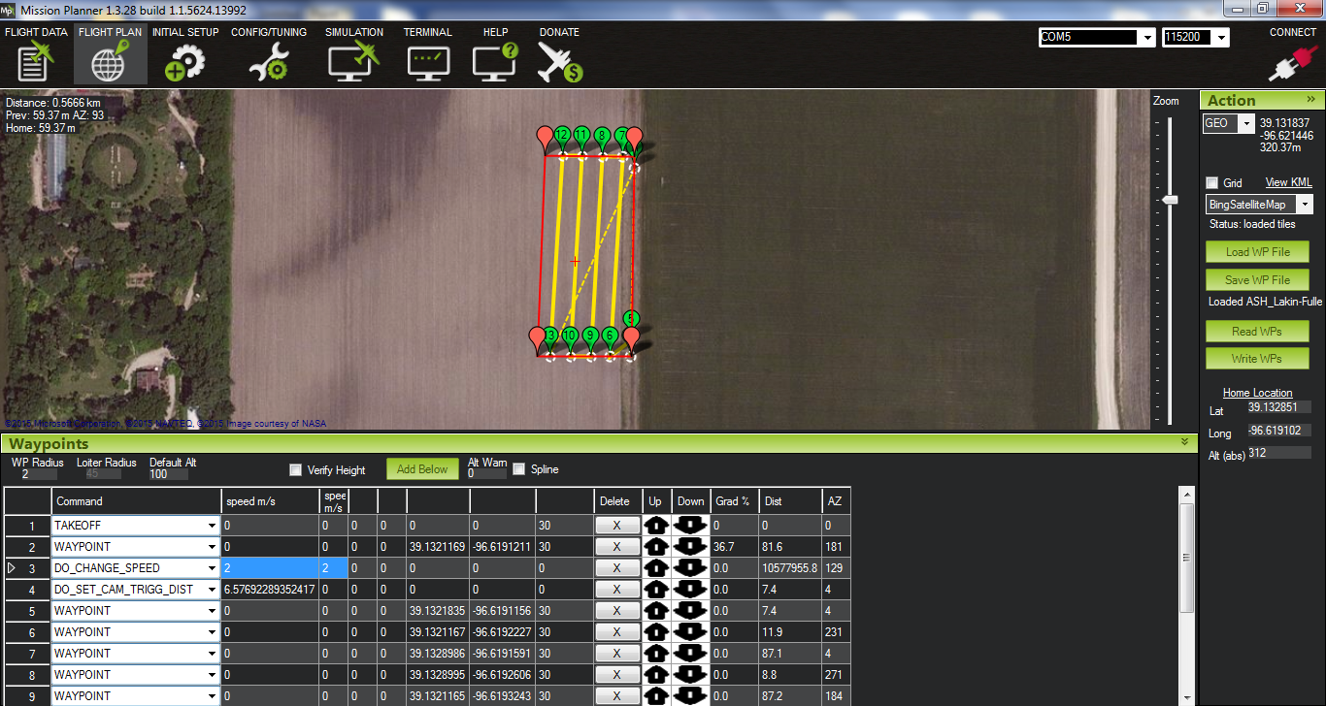

1. adadadada

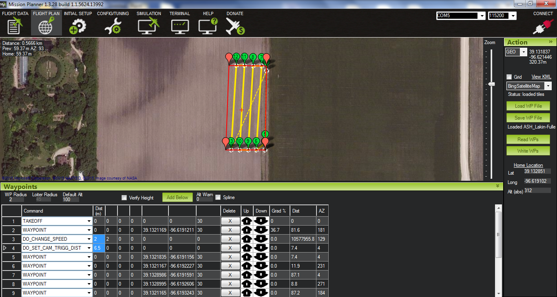

1. adadada

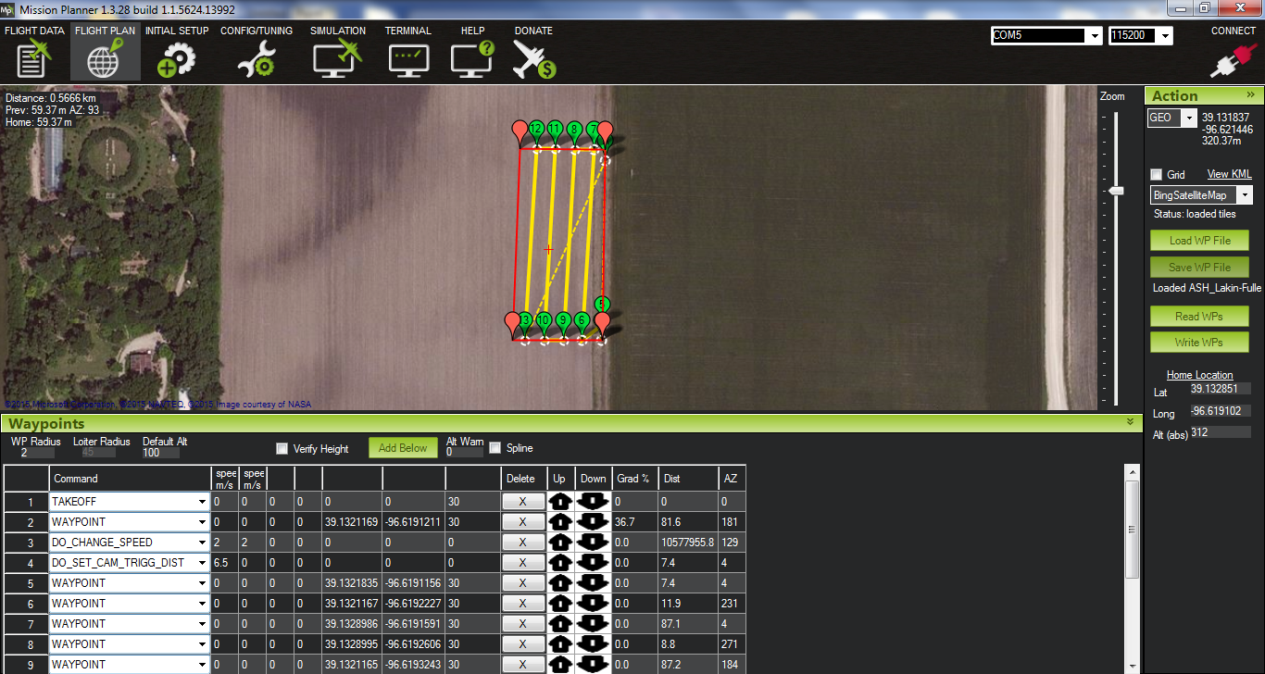

1. sadadf